**ASSIGNMENT 11.2**

PROBLEM STATEMENT:

**Perform incremental load in Hive**

**Read from MySQL Table and load it in Hive table.**

**Create hive table if it does not exist.**

**If it exists, perform the incremental load.**

Solutions:

Step 1:

Since the mysql table is created, so we are displaying the table.

Output:

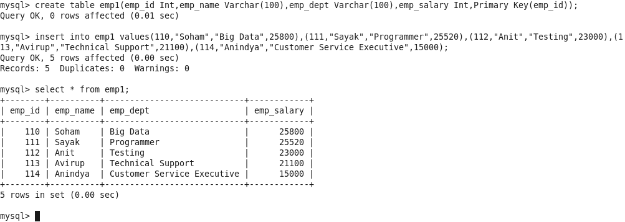

Step 2:

The hive table also exists and it is created and imported.

Output:



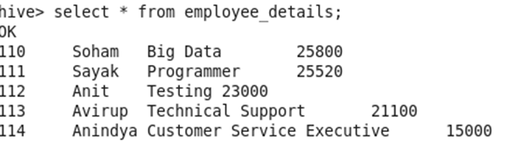

Step 3:

At the last we will do the incremental import of the data and then add to hive shell

Output:



